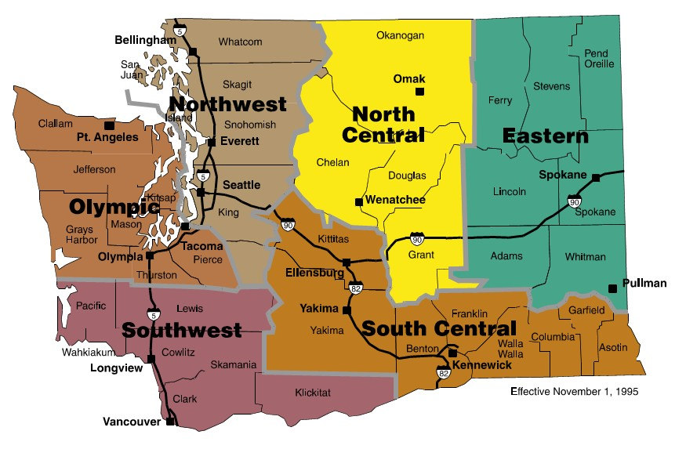
How to use this Contract:
Washington State is divided into six regions. Some contractors have agreed to provide service in all regions, while others agreed to provide service in select regions.
Please use the following steps for contractor selection:
- Review the state map to identify the appropriate region
- Use the Equipment Look-up feature on page 4 of the Pricing and Ordering Document to determine which Contractors offer the type of equipment you are seeking by region
- Click on the associated regional link on page 4 of the Pricing and Ordering Document to see all of Contractors within region selected
- Select the contractor
- Click on the Contact information tab to review contractor’s information (i.e., address, payment rules, contact personnel, etc.).
- If you have not done any prior business with a contractor, you may wish to consider establishing an account with them prior in order to expedite the first rental.
- Click on Contactor’s pricing Excel Workbook in the Pricing and Ordering Document to view pricing
- See tabs for identification of each equipment category in alphabetical order (i.e., compactors, excavators, front-end loaders, etc.)
- Click equipment choice tab
- Decide on day, week or monthly rental
- Choose pricing associated with day, week or monthly rental
- Compare pricing to competitors to ensure best pricing for your agency

All prices are FOB Origin so delivery must be negotiated with the Contractor you select for your equipment rental needs.

Special Notes:
The contract requires the contractors to offer prorated pricing on extended equipment rentals so if there are any questions related to prorating please contact the vendor for further details.
The contract also includes clarifications of Insurance Options in Appendix B, Special Terms and Conditions:
- Rental Insurance
Renters have the option to either sign a damage waiver with the contractor or obtain an Equipment Floater. Additional information on Equipment Floaters is available from the Department of Enterprise Services Risk Management.
http://des.wa.gov/services/Risk/insurance/Pages/commercialInsurancePolicies.aspx
The Insurance Floater is a state brokered insurance policy available through the Department of Enterprise Services, Office of Risk Management. This policy is highly recommended to customers to insure adequate coverage for high valued equipment for both state government owned and rental equipment.
Customers may opt to sign a damage waiver with the contractor for smaller-valued rental equipment.

